Ileana Turner – President-Elect

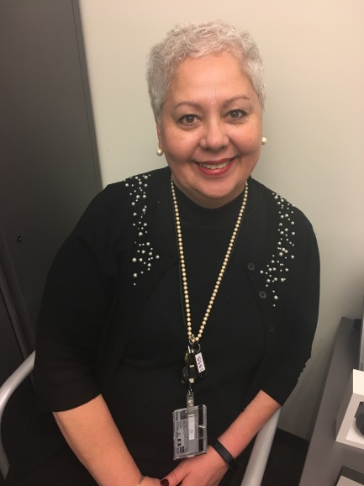

Ileana Turner received her B.S. in Human Resource Management from the University of Maryland University College. She started her federal career at NIH and has worked on both the program and service side of NIH. Ileana worked in the office of the Director, under Christine Major, as well as Employee Benefits. At FDA, Ileana works in support of CDER’s Office of Management in Diversity, Inclusion & Engagement.

Ileana joined the Montgomery County Chapter of IPMA-HR 2011 and shortly thereafter filled the seat of an at-large member. Ileana then ran for the position of Secretary of the Chapter, President-Elect, President and then Immediate Past President. Ileana has also served as Treasurer-Elect and Treasurer of the Eastern Region Board.

Ileana considers herself to be a life-time learner and is always looking for new opportunities for development and growth. She feels that IPMA-HR provides opportunities to develop competencies that are not always available in one’s position. Just as important, are the many members of that she has had the privilege of knowing and working with.

